The Great Italian Detective

Slide 1: The Great Italian Detective
- Welcome to the session called The Great Italian Detective
- In fact, there are 4 examples of recent crime series set in Italy
- Interest in the similarities and differences between them
- Question: does the location generate a distinctive style regardless of author’s origins?
- Vehicles for portraying Italian culture and society
Slide 2: Four Italian Crime Series Authors
- Four authors
- Different nationalities
- Different Italian locations
- Italian authors have background in theatre, film and tv
Slide 3: Commissario Guido Brunetti - Donna Leon
Donna Leon wrote her first Brunetti murder mystery in the early 1990s, apparently, she says, as “a kind of joke”. Nearly 30 books later, Donna Leon has notched up sales of well over two million with the Brunetti series translated into 35 languages. Born in the US in 1942, Donna Leon spent 30 years living in Venice before moving to Switzerland, where she now resides - presumably for tax purposes as well as to escape the tourists. On which, she is reported to have said that the solution to the problem of mass tourism in Venice is to fill the canals with crocodiles.
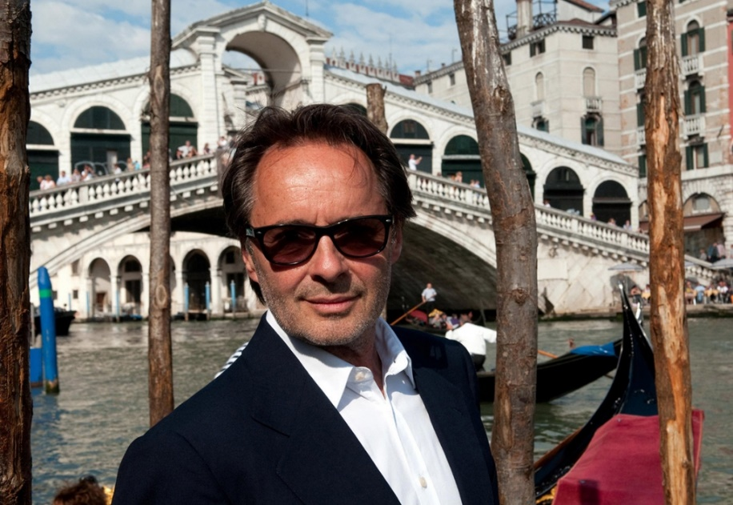
So who is Commissario Guido Brunetti? Well, not the stereotypical hard-drinking, over-worked policeman. He’s presentable and well-read. A family man who goes home for dinner. He enjoys his wine, a glass of grappa, and he loves Venetian food. I personally think Brunetti is to Donna Leon what I suspect Mr Darcy was to Jane Austen. The ideal man - not the dark and troubled soul of other crime series.
This may make the books rather too saccharine for some tastes. But they are not just about Brunetti. As we will see in the work of other Italian crime writers, the chief protagonist often has a trusted team around him. Part of the success of these novels is a strong cast of supporting players, both allies and enemies. Brunetti’s wife, Paola, is a university lecturer and the daughter of wealthy Count and Countess Falier. Marriage to Paola opens doors to Venetian aristocratic families that would otherwise be definitively closed to a policeman. Then there is Vice Questore Patti, Brunetti’s boss, an over-promoted social climber. Patti is constantly annoyed by Brunetti’s connections to the Venetian elite - an echelon of society to which Patti will never be admitted. Shades of Captain Mainwearing and Sergeant Wilson. Patti’s glamourous secretary is Signorina Elettra, always dressed in designer outfits, always with fresh flowers on her desk, she has a dark past in government administration and second-to-none computer skills that enable her to access all manner of information for Brunetti. The books are therefore ensemble pieces, the interest lying not solely with the main character, but in the interaction between all the players in this Venetian cast.
And then there is Venice itself. The books provide a portrait of a city in decay and under threat from the modern world, but still one of transcendent beauty. Brunetti lives a life of contrasts. The civilised one of drinking coffee and eating soft-shell crabs and ravioli con funghi, and the modern day reality of environmental degradation, toxic-waste scandals; people-trafficking and sex slavery; and of course, endemic corruption in government and the omnipresent Catholic Church. The contrast between the past glories of a magnificent culture and modern decadence is the underlying script of Leon’s novels.
So to illustrate the point, Alison is now going to read an excerpt from By Its Cover, where Commissario Brunetti is seeking information from a Venetian contessa, by the by related to his wife’s family, who might help to solve a case involving murder, theft, and the defacing of rare and valuable antique books at one of Venice’s ancient libraries.
*****
“What should I know about collectors? And about value?
She had clearly been waiting for this question, or one like it. “They’re very strange people, most of them. Almost all are men, and most of them like to show off”. He nodded to tell her he knew both things, and she went on. “With watches or cars or houses, it’s easy for your friends to find out what they cost. So they swoon at your new Lamborghini or your Patek Philippe. But not many people understand what books are worth”.
“So why bother to collect them?” he asked. “And why bother to steal them? Or have them stolen? All it does is make you a higher class of thief”.
She smiled at the turn of phrase. “If their friends are thieves, too, then it’s reason for more boasting”.
Brunetti had not considered this. Had we sunk so low? He thought for a moment of some of the politicians in whose libraries stolen books had been found. Yes, we had sunk that low.
“Some people collect books because they love them and see them as part of our history and culture”, she said. “You hardly need me to tell you that”.
“Was this the case with your husband’s family?” he asked
Again she laughed and again he thought she sounded like a heavy smoker. “Good God no. They acquired them as investments. And they were right. They’re worth a fortune now”.
“You’re going to give them all to the library, aren’t you?” he asked.
“I probably will”, she said. “I’d rather see them safe in a library, where people who are interested in them can read them, than think of them falling into the hands of those who see them only as repositories for money”.
As if she sensed his reaction, she abruptly asked, “Do you have any other questions?
“How much damage does cutting out a page do to a book?”
“It’s irreparable. Even if the pages are found. The book isn’t the same object any more.”
Brunetti thought it sounded like the idea of female virginity that had been current in his youth, but he thought it prudent not to voice the comparison.
“And the effect on the…” he hesitated over which word to use. Finally he decided on “price?”.
“It’s greatly decreased, even by half, if just one page is missing. The book is corrupted.”
“And if the text is untouched?”
“What do you mean?” she asked.
“If it’s intact. If the text of the book is all still there to be read?”
She couldn’t stop her mouth from contracting in a moue of disapproval. “We aren’t talking about the same thing” she said. “I´m talking about a book, and you’re talking about a text”.
Brunetti smiled and slipped the cap on to his pen. “I think we are both talking about the same thing Contessa: books. We’re just defining them differently.” He got to his feet.
“Is that all?” she asked, surprised.
“Yes” Brunetti said. “You’ve been generous with your time and your knowledge, Contessa”.
He closed his notebook and put it in the inside pocket of his jacket. She handed him back the papers, taking one last look at Nickerson’s passport photo. He slipped them into his briefcase.
She watched him snap it closed. He got to his feet and she rose from her chair and moved towards the door.
“Again, thank you for your time, Contessa, “· he said, pausing at the door.
She put her hand on the handle but made no move to press it down. Instead she looked at him and smiled. “If you want to know what texts are worth, Guido”, she said, calling him by name and using the familiar tu she had denied him during their conversation, “take a walk over to Rio Terá Secondo”. He raised his eyebrows but said nothing. “You’ll find the building where Manutius’ printing press was. You don’t need me to tell you it is the most important printing press in the history of the Western world.
“There are two plaques on the wall of the building. One of them announces that it is the site of the Aldine Press, “which returned the splendour of Greek literature to civilized people”. It was put there by the School of Greek literature. In Padua. On the ground floor, on the right, there’s an abandoned shop, and on the left there’s a shop selling tourist junk. The day I found it, I asked in four shops nearby, but no one knows who Aldus Manutius was”.
*****
There is more discussion on this theme later on in the book, and rightly, as through the narrative Donna Leon is simultaneously pointing to Venice’s key place in the history of Western knowledge and also commenting on the values of today’s Venetian society. Aldus Manutius, by the way, was an Italian scholar with a keen eye for new opportunities presented by the development of the printing press, and who moved to Venice in 1489 to exploit this. A few years later he set up the Aldine Press, famous for bringing classical Greek texts in the original to an educated Venetian and European audience. In 1500 there were around 30 printing presses in Venice, but Manutius’ was the most significant. He invented the italic script, small-format books, clearly legible Greek fonts, the semicolon and many other innovations. In the first few years of the 16th Century, his printing press was the intellectual heart of the city of Venice. As well as being a brilliant entrepreneur, Manutius was also a scholar, rather than simply a craftsman printer. For him, the text was what counted, the printed book a superb means a disseminating the knowledge found within.
So the discussion about the value of the “text” and the “book” points to Venice past role as the knowledge capital of the world, contrasting this with its fall into the present day decadence, a comparison so succinctly drawn in this conversation.
Slide 4: Aurelio Zen - Michael Dibdin’s Cynical Sleuth
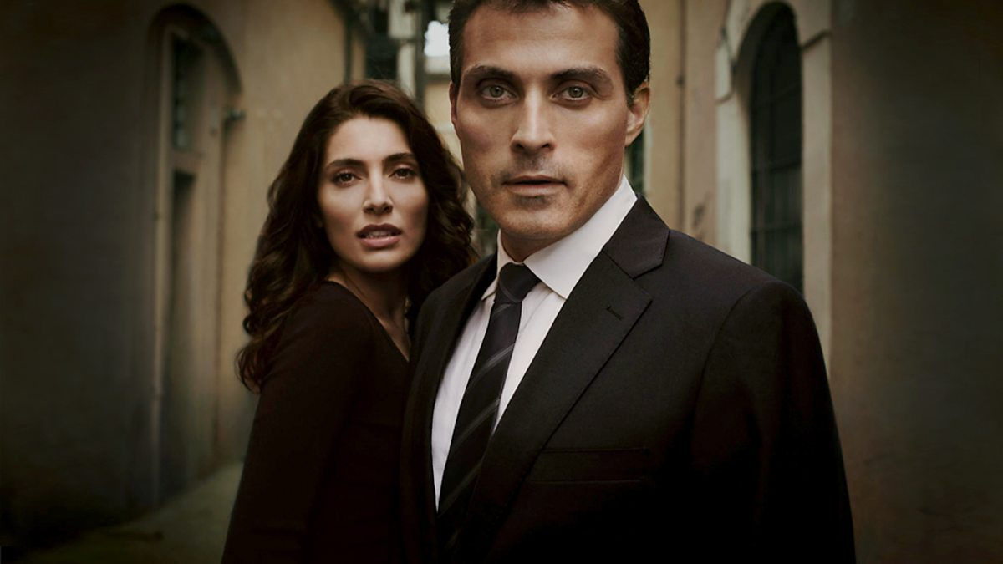
Michael John Dibdin was born on March 21, 1947, in Wolverhampton. Rather bizarrely, his father gave up a career as a physicist to devote his time to folklore, the family spending years wandering Britain so that the elder Mr. Dibdin could collect folk songs. So after a peripatetic childhood, the young Dibden gained a degree in English literature from the University of Sussex, and then went on to complete his masters at the University of Alberta, in Canada. He stayed in Canada for several years working as a house painter, before moving to London and then on to Italy.
He spent four years teaching English in Perugia before returning to the UK where he settled in Oxford for a time before moving to the States in the 1990s.
Dibdin’s crime writing career began with two pastiches: “The Last Sherlock Holmes Story” (Pantheon, 1978), and “A Rich Full Death” (Vintage, 1999), the latter set in Florence. However, he struck gold when he created his fictional detective Aurelio Zen, a Venetian Carabiniere who is posted to various locations across Italy to solve crimes, usually those that politically savvy career policemen avoid like the plague.
Unlike Donna Leon’s Brunetti, Zen is a darker character, refined, aloof and reticent, a "philosophical observer who looks on with wry amusement at the follies of others but is too wily and cynical to risk becoming entangled himself". A rather lonely figure, he still maintains close ties with his mother, in a rather stereotypical Italian fashion. And although women find him attractive, he's too modest, or too focused on work, to notice. He longs to return to his native Venice, but is always diverted by the need to solve one last crime – in order to prove to himself. Like another of our fictional Italian detectives, Rocco Schiavone, he has a past. In Zen’s case, the sin committed in the eyes of powerful political interests was to discover too much about the kidnapping of Aldo Moro. It cost him his career prospects.
But the books are once again about more than the central character or the crime under investigation. Zen is a vehicle for Dibdin’s observations on the Italy of eighties and nineties, its culture, its people, and politics. It was his time in Perugia that provided the impetus for the first book in the Zen series – Ratking. I think Dibdin is less dazzled by Italy’s past than Donna Leon, is more interested in the here and now, and shows a rather more detached and ironic eye. In a Guardian review in 2002, Tobias Jones commented “Dibdin has an eye for everything the guidebooks never quite capture: the surreal graffiti, the scams, the cynicism, the beautiful nicknaming, the monopoly-money banknotes (now vanishing from circulation), and of course the paranoia”.
This paranoia provides the backdrop for probably the most successful books in the Zen series: Ratking, Cabal, Vendetta and Dead Lagoon. But in order to avoid a spoiler for those of you who haven’t read the books and might like to, Tony is going to read a scene from another book in the series, Cosí Fan Tutti, in which Zen has transferred from Rome to the post of Inspector of the police detachment at the port of Naples and is facing a hostile team of locals.
*****
“One of the first effects of Zen’s posting to Naples, predating his actual arrival, had been the hasty closure of various profitable and long-established business enterprises operating from the police station inside the port area, much to the distress of all involved. This painful decision had been reluctantly taken after an emergency meeting of the management and staff. It was the first time that anyone could remember an outsider being appointed to command the harbour detail. And not just any outsider, but a former operative of the illustrious Criminalpol, who worked directly with the Ministry in Rome!
For such a high-flyer to be transferred to a lowly routine job in the South could mean only one thing, they all agreed. A clean-up had been ordered, and Zen – his name didn´t even sound Italian – had been selected to enforce it with ruthless efficiency. The only mystery was why their modest little scam had been singled out in this way when, as everyone knew, there was so much serious, big-time abuse going on. But perhaps that was precisely the point, someone suggested. The men at the ministry didn’t dare touch the big names, to whom they were too closely linked and indebted, so they were making a show of doing something by sending on of their hatchet men to pick on the low level activities in which they took no direct interest.
Zen’s first job was to convince his new colleagues that this was not the case. It proved to be the one of the toughest assignments he had ever faced. After holding out for over three weeks, during which time he had made no progress whatsoever, he finally decided to do something completely uncharacteristic, something so foreign to his nature that he debated the wisdom of the move right up to the last minute, and only then went ahead because there was no alternative. He decided to tell them the truth.
Since he could hardly convene the entire corps for this purpose, he deliberately selected the most hostile and truculent of the officers under his command, Giovan Battista Caputo. Caputo was a wiry, energetic man in his early thirties with a prow-shaped face, a hook nose, a flamboyant black moustache and a mouthful of sharp white teeth which were exposed up to the gums when he flashed one of this infrequent, vaguely menacing, smiles. He look like a composite of every gene pool which had every flourished around the bay; Etruscan traders, Greek settlers, Roman playboys, Barbary pirates and Spanish imperialists. If he could win over Caputo, Zen reckoned, he would win the keys not only to his new command, but to the city itself.
You’re all wondering what I’m doing here,” he declared when Caputo presented himself in his office.
“That’s none of our business”, was the unyielding reply.
“I’m going to tell you anyway”, said Zen. “Sit down”.
“I’d prefer to stand”.
“I don’t give a damn what you prefer. I’m ordering you to sit down”.
Caputo obeyed stiffly.
“The answer to the question I raised is very simple” Zen went on. “I requested a transfer”.
For all the effect of these words on Caputo, Zen might just as well not have spoken.
“You don’t believe me” Zen remarked.
“It’s none of our business” repeated Caputo stolidly.
“And it’s easy to see why you don’t,” continued Zen. “Why should anyone request a transfer from the capital to a posting in a provincial city where he has no family, no friends, and doesn’t speak the dialect? And not even to the main Questura but to a dead-end job with the port detail?”
Caputo looked Zen in the eye for the first time, but still offered no comment. Zen took out his pack of Nazionali and offered one to his subordinate, who shook his head.
“The answer to this question is not so simple,” Zen said, exhaling a cloud of smoke. “To use a classical allusion, I had to choose between Scylla and Charybdis. I had made enemies at the ministry, powerful enemies. I knew they would not let me continue in my previous job, and I suspected that they might attempt to send me to a punishment posting. My only hope was to anticipate them by applying for such a move myself. I took a look at the positions vacant and chose this one. I’m the correct rank to command this detachment, and since it effectively constitutes a massive demotion from my former position with Criminalpol, my enemies could not intervene without revealing their hand. I had accepted defeat, but on my terms, not theirs”.
“Who are your enemies?” whispered Caputo, all attention now.
“Political”.
“On the right or the left?”
Zen smiled condescendingly. “No one uses those words anymore, Caputo. We’re all in the centre nowadays. And my enemies are about as close to the centre as it’s possible to be. In fact, at the time of which I am speaking, one of their number was the Minister of the Interior.”
Caputo’s eyes widened.
“You mean…?”
“I do indeed.”
Caputo licked his lips nervously.
“Maybe I will have a cigarette after all,” he said.
Zen pushed the packet across the desk.
“That explains what I am doing here” he said. “It also explains my total lack of interest in any and all aspects of my job. This posting has been forced on me as the least of various evils on offer, but I do not feel the slightest degree of professional involvement or responsibility. I am sure that you and your colleagues are perfectly capable of carrying out your duties in a satisfactory manner, and my only wish is to leave you free to do so without interference or supervision. In short, just pretend I´m not here and carry on as you have always done. Do I make myself clear?”
Caputo flashed his shark’s smile.
“Yes, sir”.
“The only thing that concerns me is that nothing occurs which might draw unwelcome attention to this detachment, and hence give my enemies an excuse to move me to the killing fields of Sicily or some God-forsaken hole up in the mountains. I’m sure I can count on your experience and discretion, Caputo, to ensure this does not happen. As far as everything else is concerned, I leave matters entirely in your hands. In fact, the less I know about it, the better pleased I shall be.”
Caputo nodded briskly and stood up.
“Will there be anything else sir?”
Zen was about to shake his head when a though struck him.
“Acutally, I’d like cappuccino scuro. Not too hot, lots of foam, no chocolate.”
He lay back, glancing at the clock on the wall. Less than five minutes later a uniformed patrolman entered bearing a tray laden with a glass of mineral water, a selection of baked pastries, and the cappuccino. Every morning after that, an identical tray appeared a few minutes after Zen’s arrival at the office. For a while, that was all. Then, about three weeks after his conversation with Caputo, he came in one day to find a large cardboard box in the corner of the room. It proved to contain fifty cartons of Nazionali, 10,000 cigarettes in all. Zen removed three cartons and took them home. He stacked the rest in the empty drawers of his filing cabinet.
After that, things improved by leaps and bounds. He was greeted in respectful fashion by everyone he met, and his orders and requests were obeyed with alacrity, sometimes before he even realised that he had made them.
He normally showed up at work each morning about eleven, unless he had something better to do, leaving again shortly before lunch. Today he was entertaining Valeria at home, so he planned to make no more than a token appearance before stopping by the market to shop for whatever took his fancy……
He walked in through the open doorway, acknowledging the greeting of the three uniformed men lounging about in the hall, and climbed the stairs to his office on the first floor. The trio discreetly broke off their conversation until he had reached the landing and then resumed in a low tone. The murmur of their voices reach up through the cool, shadowy spaces of the stairwell like the distant drone of bees.
He had been in the office barely a minute when there was a knock at his door.
“Avanti!” called Zen, surprised and pleased that his cappuccino had arrived so quickly.
But it was Giovan Battista Caputo who appeared. His manner was unusually subdued. ”Sorry to disturb you, chief. Can I have a word?”
Zen waved his hand wearily.
“We had a spot of bother last night,” Caputo announced, coming in and closing the door.
*****
So Zen’s comfortable existence is destined once again to be complicated, this time by a case involving stolen software, the murder of several prominent Naples businessmen, and his side line project for a wealthy Naples woman who wants to protect her daughters from the advances of two unacceptable suitors, apparently from the shady world of the Naples Camorra.
Dibdin, who died at the age of 60 in 2007, reflects in this and other Zen novels the most Italian of notions that behind all significant political events, acts of terror, or even disaster, lies a shadowy network of puppet masters – politicians, secret services, business moguls, freemasons – pulling the strings for their own nefarious purposes. Zen’s original sin against the system, one that informs the whole series, was to find out too much about the Aldo Moro case. As many of you may recall, this was the assassination of ex-Prime Minister and statesman Aldo Moro by the Red Brigades, a left wing terrorist group.
Aldo Moro was kidnapped in March 1978 and held captive in a specially constructed cell in an apartment in the south of Rome over a period of seven weeks. The kidnapping took place as he made his way to Parliament, where a power sharing agreement between the ruling Christian Democrat Party under Giulio Andreotti and the Communist Party led by Enrico Berlinguer was about to be signed. Five police officers were shot dead in the ambush. The Red Brigades were demanding the release of 16 “brigatisti” held in Italian prisons. During his time in captivity he was allowed to send letters to family, the Pope, and Party colleagues, the latter in particular being the vehicle to achieving the Red Brigades secondary objective of revealing corruption at the heart of the State. Moro obliged, but was eventually murdered, his body found in the back of an abandoned Renault 4 in the Via Michaelangelo Caetani in central Rome. The location was exactly half way between the headquarters of the Christian Democrat and the Communist Parties.
There have been many claims that the kidnapping and murder was staged not by the Red Brigades but by the Masonic Lodge P2. When Dibdin was starting to write his novels, in the late 80s and early 90s, information about the involvement of P2 was very much in the news and I suspect this was what he referred to as the Cabal. It is certainly true there are a lot of unanswered questions about the Moro case, not least around the bungled police operations attempting to find Moro and his kidnappers. And especially considering that US State Department official, Steve R. Pieczenik, who was dispatched by President Jimmy Carter to assist the Italians during the crisis, apparently later stated: “We had to sacrifice Aldo Moro to maintain the stability of Italy.”
Small wonder that conspiracy and corruption form the set for Dibdin’s novels. The underlying message from the Zen series is that in Italy, just because you’re paranoid, it doesn’t mean they aren’t out to get you.
Slide 5: Salvo Montalbano - Andrea Camilleri’s True Sicilians
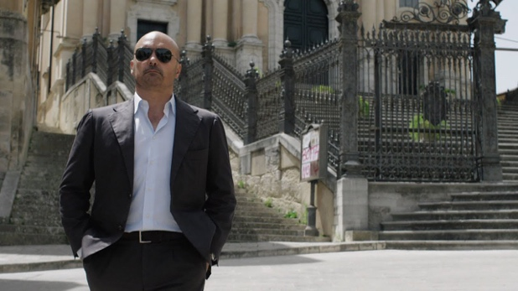
I suspect many of you will know Inspector Montalbano thanks to the excellent series produced by Italian State Broadcaster RAI and shown on BBC 4 in the UK, and here in Spain, on TVE2. In case you don’t, here is a trailer for the series:

RUN TRAILER
https://youtu.be/RW-OuoLOvs4
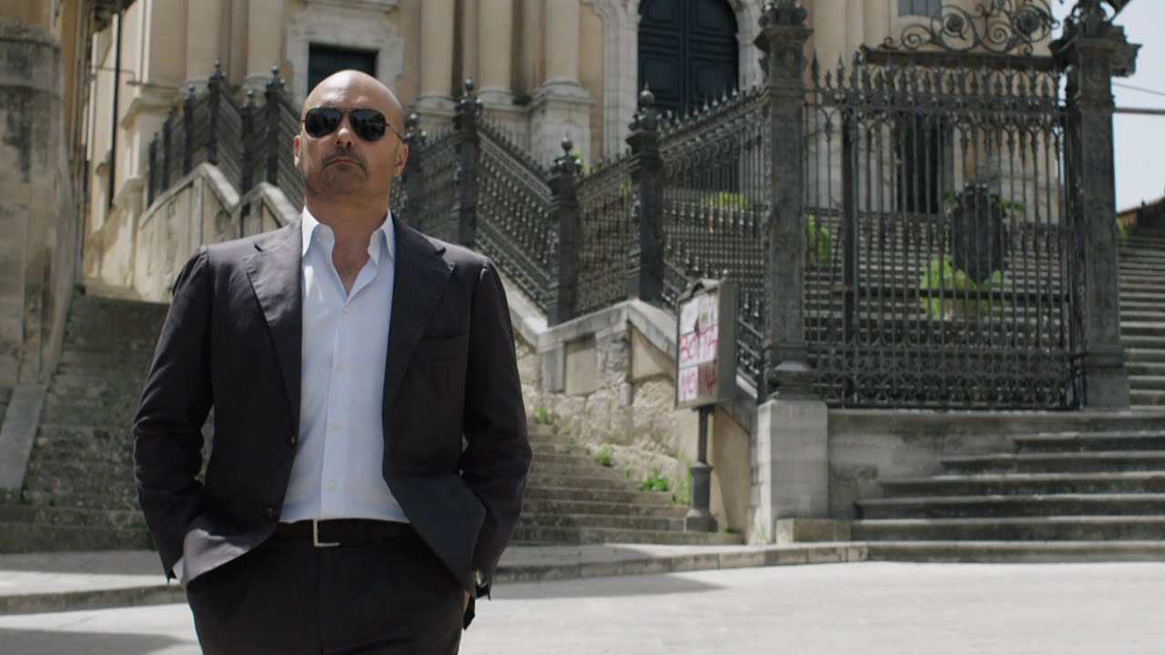
The author and creator of Sicilian detective Salvo Montalbano, Andrea Camilleri, started writing this hugely successful series of books very late in life. The first book was published when he was 68. Despite the late start, however, he went on to sell more than 10 million books that were translated into more than 30 languages and adapted for an internationally successful television series. It was Montalbano’s success on screen that turned Porto Empedocle, called Vigata in the television series, into a holiday destination for his many fans. So proud was the town of its most famous son’s literary creation that from 2003 to 2009 it called itself Porto Empedocle Vigata.
The only son of Carmelina and Giuseppe Camilleri, Andrea grew up in the town of Porto Empedocle on the Sicilian west coast during Mussolini’s dictatorship. His father was a harbour official who had taken an active part in the fascists’ rise to power. Camilleri eventually found his vocation as a theatre director, to which he dedicated most of his working life, before turning to writing.
Camilleri named his hero after the Spanish author Manuel Vázquez Montalbán, and admitted he had given him some of the traits of Montalbán’s gourmet investigator, Pepe Carvalho. It has to be said that there is more than a touch of the “production line” to Camilleri’s output. He certainly churned them out as you can see from the publications list. But in an important respect, the Montalbano stories were utterly original. They are written in a language of the author’s creation: a blend of standard Italian and Sicilian dialect. Because of this, there was a lot of debate about whether and how the books could be translated on to the small screen. But the director and production team went with it and the rest is history.
Camilleri’s detective, Commissario Salvo Montalbano, is not unlike our two previous protagonists: a man who pieces together clues out of coincidences, and who has an acute moral conscience, while being worldly enough to understand how to play the game, including how to handle the local mafia. And then there is the food. Celebration of the wonderful food of Sicily forms an integral part of the narrative, just as Venetian cuisine is a star of the Brunetti novels. Nothing must interrupt worship at the table of Sicilian cuisine. No matter what the case, everything stops for lunch at one of his favourite restaurants. Perhaps this is one of the reasons why he stays in Vigata. He has opted for la dolce vita a la Siciliana in preference to a career ladder that would inevitably lead to Rome and compromises he is not prepared to make.
Camilleri gives us a vivid cast of Sicilian characters to match the chief protagonist. From the talented though rather earnest Sergeant Fazio and then Inspector “Mimi”, who can never resist chasing a bit of skirt, patrolman Catarella, who has difficulty getting anybody’s name right, and Pasquano, the grumpy local forensic pathologist, Camilleri’s characters develop as the series progresses, revealing a richer portrait of Sicily and the Sicilians with every case to solve.
In particular, the books are full of the earthy humour of the Sicilians, who at every turn demonstrate a very Sicilian disrespect for the authorities, especially the police. And at times you can see why. Here is Montalbano leading his team in the capture of a Mafia boss, Tano the Greek, at an isolated cottage in the hills. What the team don’t know is that the whole thing has been cooked up. Tano actually wants to be detained, for his own reasons, and has persuaded Montalbano to stage the charade in return for his capture.
******
“Stop in the name of the law! Stop or I’ll shoot!” he shouted at the top of his lungs, then fired four shots into the ceiling. Tano froze, hands raised. Convinced that someone must be hiding upstairs, Galluzzo fired a burst from his machine gun at the wooden staircase. Outside, Fazio and Gallo, upon hearing all the shooting, opened fire on the little window to discourage anyone from trying that route. With everyone inside the cottage still deaf from the roar of the gunshots, Germaná burst in with the final flourish.
“Don’t anybody move or I’ll shoot!”
He barely had time to finish uttering his threat when he was bumped from behind by Fazio and Galluzzo, who, having set down his weapon, was dabbing his nose with a handkerchief he had taken out of his pocket, the blood having already dripped onto his shirt, tie and jacket. At the sight of him, Gallo because agitated.
“Did he shoot you? The bastard shot you, didn’t he?” he yelled in rage, turning towards Tano, who was still standing as patient as a saint in the middle of the room, hands raised, waiting for the forces of law and order to put some order into the great confusion they were creating.
“No, he didn’t shoot me, I ran into the wall”, Galluzzo managed to say with some difficulty. Tano avoided their eyes, looking down at his shoes.
He thinks it’s funny, thought Montalbano, then he brusquely ordered Galluzzo, “Handcuff him”.
“Is it him?” Fazio asked in a soft voice.
“Sure it’s him. Don’t you recognize him?” said Montalbano.
“What do we do now?”
“Put him in the car and take him to police headquarters in Montelusa. On the way, ring up the commissioner and explain everything. Make sure nobody sees or recognizes the prisoner. The arrest, for the moment, has to remain top secret. Now go.”
“What about you?”
“I’m going to have a look round, search the house. You never know.”
Fazio and the officers, holding the handcuffed Tano between them, started moving towards the door, with Germaná holding the prisoner’s Kalishnikov in his hand. Only then did Tano the Greek raise his head and look momentarily at Montalbano. The inspector noticed that the statue-like gaze was gone; now those eyes were animated, almost smiling.
When the group of five had vanished from sight at the bottom of the path, Montalbano went back inside the cottage to being his search. In fact, he opened the cupboard, grabbed the bottle of wine, which was still half full, and went and sat in the shade of an olive tree, to drink it down in peace. The capture of a dangerous fugitive had been brought to a successful conclusion.
******
On the subject of the Mafia, you might expect this to dominate the books. This is, after all, Sicily. But while the local Mafia inevitably forms a background to the stories, as in the last extract, it is seldom the main focus. Camilleri paints a more rounded picture of the land he loves, drawn no doubt from his early years living in the small town of Porto Empedocle. Had he been a Palermitano born and bred, we can speculate that his novels would have been darker. The Mafia were heavily involved in Palermo’s construction boom from the 1950s through to the 1980s. The high point was when the Christian Democrat Salvo Lima was mayor of Palermo (1958-1963 and 1965-1968) and Vito Ciancimino the assessor for public works. They supported Mafia-allied building contractors such as Palermo’s leading construction “entrepreneur” Francesco Vassallo – a former cart driver from a poor district of Palermo. Over the course of 5 years, 4,000 building licences were signed, some 2,500 in the names of three pensioners who had no connection with construction at all.
We digress. But perhaps in writing the Montalbano series, and because Camilleri draws on a life away from Palermo, he has done his native land a big favour. He may not have entirely broken the spell of the Mafia over Sicily, but maybe his books have helped to shift, ever so slightly, the perspective of outsiders.
Camilleri died at the ripe old age of 93 in July this year. I suspect that when he started writing Montalbano back in the sixties, and after an illustrious career in the theatre, he never imagined that his chief legacy would be the detective stories that are his long love letter to Sicily.
Slide 6: Rocco Schiavone - Antonio Manzini
And so to our last Great Italian detective, and one that I think may turn out to be the greatest of them all. You remember that comment by Zen earlier on about his nightmare scenario? The nightmare scenario for any Italian detective?

To recap: “The only thing that concerns me is that nothing occurs which might draw unwelcome attention to this detachment, and hence give my enemies an excuse to move me to the killing fields of Sicily or some God-forsaken hole up in the mountains”. Well, the God forsaken hole up in the mountains is the fate of our final detective: Vice-Questore Rocco Schiavone.
He is the creation of author Antonio Manzini, a Roman by birth and native of the Trastevere district. Like Camilleri, Manzini is a theatre and film director. He has also had a successful career as an actor (adaptation of 'Los hombres de Paco', where he played the rough round the edges police detective). But his real success has been the Rocco Schiavone crime series, following in the footsteps of Andrea Camilleri (he is friends with the author) and at times threatening to overtake Camilleri’s place as Italy’s number one novelist. There are 10 books in the series so far and all have been translated into a hit TV series by RAI.
The chief protagonist of Manzini’s novels is the Assistant Commissioner of Police in the Alpine region of Valle de Aosta. Vice Questore Schiavone is not, however, a local. A Roman to the core, detesting the cold, he has been transferred from Rome to Valle de Aosta as punishment for administering a beating to a serial rapist who has evaded justice as he is the son of a high ranking Roman family. Pot smoking Schiavone is not exactly dishonest, but he is not averse to crossing the line between the legal and illegal and applies his own code of ethics. For example, you can rob from a thief, but never from an honest person. The son of a very poor Roman family, he knows that in this world justice is all too often only accessible by, and granted to, the rich. He can be nasty and insensitive, but he is sincere and has maintained a life-long friendship with three school friends, including a safe-cracker, who from time to time assist in solving cases, and as well as getting him out of a tight spot.
Manzini says of Schiavone and of his native Rome: “There is something very Roman about him: that generosity and sincerity. It is something that no longer exists. What is a real Roman? When I was a child, it was a person who was open, sincere, welcoming, smiling and who cared for the weakest. This was a city that welcomed pilgrims that came in their thousands. A city that always welcomed the world with open arms. The Roman opens their arms to you…but, careful, they may pinch your bag. That was Rome, and Schiavone is a bit like this. But this no longer exists. Now the Roman is someone bitter, complaining, closed, someone who dirties their own city”. Small wonder then that in the first book in the series “Black Run” the theme of illegal migration crops up as Schiavone and Inspector Pierron intercept an HGV they have been tipped off is carrying a shipment of arms. As well as sub-machine guns and rocket launchers, they also find it full of Malian migrants. Incidentally, illegal migration is also a recurrent theme in the Montalbano series and an episode recently drew a lot of criticism from Salvini’s far right party, as Montalbano was seen as being pro-migrant.
Once again there is a strong cast of characters in this series, each personality with their own history and hang-ups, from Detective Pierron’s gambling addiction, to the talented Inspector Caterina Rispoli, whose abusive father has left her psychologically scarred. Then there are the foot soldiers in the squad, Casella, D’Intino and Derruta, who often provide a comic element. Not to mention the three Roman friends from Schiavone’s childhood who on several occasions help him get results not possible through official channels, not to mention disposing of a dead body in the time honoured way: in the cement footings of a motorway flyover.
So Schiavone is no Montalbano. And there are other differences. When Rocco Schiavone opens the fridge, there is nothing in it except a half bottle of wine and some mouldy bread.
Here is a clip from the series, first of all showing him updating the judge on progress on a prison murder, accompanied by his new constant companion. Next we switch to a scene in which he is a rather uncomfortable guest, courtesy of one of his girlfriends, at the party of a wealthy Val d’Aosta resident, one Turrini, whose wife is head of a local bank and is implicated in involving one of her business clients in mafia financing, resulting in the kidnap and rape of the businessman’s daughter.
RUN DVD
Perhaps the key difference with the Schiavone series is that it is clearly conceived as having a beginning and an end. It is not solely a series of “cases” for our detective to solve that go on as long as the author, and their public, maintain their interest. There is an underlying story about Schiavone that unfolds book by book. It is still unfolding. Manzini and Schiavone have not reached the end just yet, but there is a clear trajectory even if the reader cannot know what the ending will be. You have to read these books in the order in which they were written.
This series and its protagonist are more complex in their conception than Brunetti, Zen and Montalbano. There is great humour in the series, as in Montalbano, but great also tragedy in a way that is not so evident in our other three examples. This is why I think Schiavone is the greatest of our 4 great Italian detectives. If you haven’t read the books and you like this genre, you are in for a treat.
And on this note, it appears that only the first 4 books have so far been translated into English. Hopefully there will be more, and the series will also become available with English sub-titles in due course.
Slide 7: Decadence, Corruption, Humour and Tragedy
To sum up, the four detective series we have looked at are by two Italian, one British and one American author. As we have seen, there are differences. Yet there are many features that bind them and make them a “set” though the balance may be different for each author: Decadence, Corruption, Humour, Tragedy.
What they are not about is some deep psychological study of why a perpetrator commits a crime, or indeed, the psychology of those who hunt the perpetrators. They are not focused on the existential, the analysis of the individual, but rather on the social.
Slide 8: A Portrait of Il Bel Paese
What they provide are brilliant portraits of Italy, its regions and people, and often, its food. This has not been missed by commentators as you can see from the selection of books on exactly this theme. But are all crime series from other parts of the world designed as similar vehicles? To a certain extent, they must be, as crimes by their very nature take place in a social context. Maybe those of you who are keen on Scandi Noir have a view. However, my conclusion is that what all our writers have in common is a fascination with Italian culture, society and politics. The detective novel simply provides them a superb vehicle for exploring these themes.
In conclusion I’d say the most forensic assessment is probably provided by Dibdin, whose principal theme is the corruption that seeps from on high to infect every pore of Italian society. Donna Leon is clearly in love with the history of Venice and her work is a lament for its past glories and about its current decadence. But the truly operatic portraiture of Italy can be seen in the work of Camilleri and Manzini, - humour most evident in the Montalbano series and tragedy in Schiavone. Their work displays a chiaroscuro technique worthy of Caravaggio. The dark may be very dark, but the light is glorious. And that just about sums up Italy.

Slide 9: Grazie Mille
- Concludes the presentation
- With thanks to

