Obituary: Javier Marías
From El Pais, written by Javier Rodriguez Marcos.

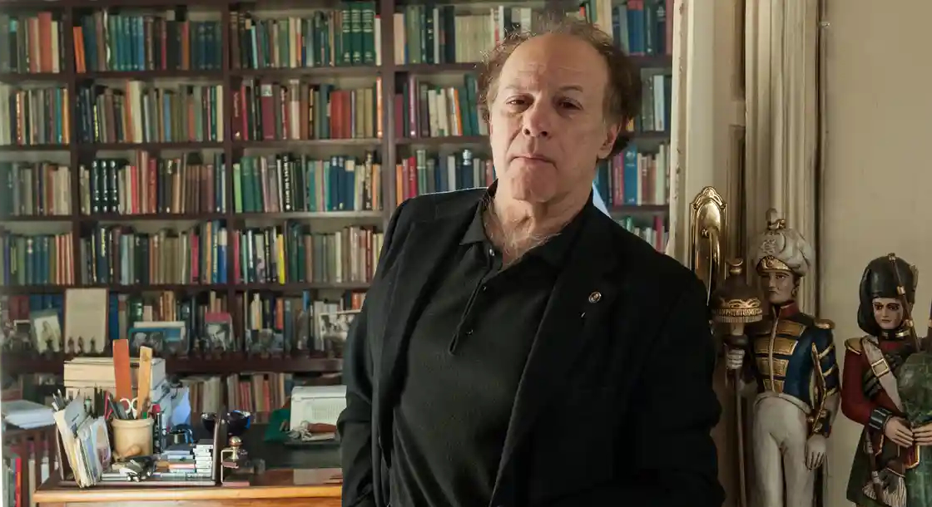

The writer Javier Marías, author of novels including A Heart So White, All Souls, Dark Back of Time and Tomás Nevinson, has died in Madrid at the age of 70, his family confirmed on Sunday.
Born in the Spanish capital, an academic of the Spanish language and a contributor to EL PAÍS, Marías made his debut as an author in 1971 at the age of 19 with Los dominios del lobo (or The wolf’s domains), a novel written “during the mornings” – he had always considered himself a “evening time” writer - in the Parisian apartment of his uncle, the filmmaker Jesús Franco, for whom he had translated scripts about Dracula. His debut is dedicated to his mentor Juan Benet, who negotiated with the Edhasa publishing house to get it into print, and his friend Vicente Molina Foix, who “gifted” him its title.

For many years, Marías combined writing and translating with lecturing at Madrid’s Complutense University. In 1979, his version of Laurence Stern’s Tristram Shandy won the Spanish National Award for translation and he would earn the same accolade in 2012 in the narrative category for The Infatuations, but as he had announced in advance, he refused to accept. That decision, which was based on the distinctions laid out by the Spanish state, also affected his view of the Cervantes Prize, which he did not win, but not the Nobel, for which he was nominated. Even so, Marías collected some of the most important international literature awards, from Venezuela’s Rómulo Gallegos Prize to the Dublin Literary Award and the Prix Formentor as well as the Nelly Sachs Prize.
After winning the Herralde Prize for The Man of Feeling (1986) and inaugurating his “Oxford cycle” with All Souls, Marías’ work came to international prominence with the 1992 publication of a A Heart So White, which won the Spanish Critics’ Award. In this critically acclaimed novel, Marías’ unmistakable first-person was crystallized, which sought to synthesize narration and reflection in long paragraphs that – in the service of a mysterious plot point or a moral dilemma – obsessively reproduces the meandering train of thought. Later came Tomorrow in the Battle Think on Me (1994) and, at a time when the word autofiction was barely used in Spain, Dark Back of Time, in which a new twist on All Souls was provided.
Between 2002 and 2007, Marías embarked on his magnum opus: the monumental trilogy that under the title Your Face Tomorrow, his approach to the Spanish Civil War through an incident inspired by the denunciation of his father, a philosopher and disciple of José Ortega y Gasset. Imprisoned as a Republican sympathizer, Julián Marías was forbidden from teaching at universities during the Franco regime for refusing to sign his name to the principles of the Nationalist movement. That forced him to make regular trips to the United States to be able to lecture and as such Javier Marías spent the first year of his life in Massachusetts, near Wellesley College, where his father was a visiting professor. The Marías’ were guests at the home of the poet Jorge Guillén and counted Vladimir Nabokov among their neighbors. Marías would end up translating his poems and who he portrayed in the Written Lives volume, a legendary compilation of profiles published in Claves magazine, founded by his friend Fernando Savater.
When it appeared that the Your Face Tomorrow trilogy had closed the cycle of work produced by the mature Marías – throughout the 1950s he was still known as the “young Marías”, his father being Marías senior – he returned to fiction with a series of successful novels: The Infatuations, Thus Bad Begins, Berta Isla and Tomás Nevinson. In a prologue added to the 50th anniversary commemorative edition of The wolf’s domains - his debut novel if we discard the raw and still unpublished La víspera (or, The day before) – Marías noted that, in answer to the frequent question of why he wrote, he tended to reply half in jest: “So I don’t have to suffer a boss and I don’t have to wake up early or work fixed hours.” He also stated that the office of a writer was not “the best way for a lazy person to spend his life.”
“Sometimes I put my head in my hands, conscious as I am that every page has been patiently written and re-written, always on paper and typewriter, with corrections done by hand and then typed out again.” Furthermore, for years, Marías believed “I will not live long, who knows why.” What he never imagined then, he said, was that the “almost childish game” of writing would lead him to “work so much.”
His final book, ¿Será buena persona el cocinero? (or, will the cook be a good person?) arrived in bookshops last February. It is a compilation of columns published between 2019 and 2021 in El País Semanal, where he had occupied the back page for almost two decades. “More than 900 Sundays,” he liked to recall, somewhere between punctilious and resigned as he felt he had “never managed to convince anybody of anything.” For years, he remained the last regular contributor who sent his articles to the newsroom via fax. His only nod to technology was using WhatsApp later to send the pages after photographing the pages that emerged from an Olympia Carrera Deluxe, which he ironically linked his destiny to: when the machine stops working, he would day, I’ll stop writing.
Marías was one of Spain’s most international writers of all time. His works have been translated into 44 languages in 57 countries, selling more than eight million copies worldwide. In one of his final interviews last May, he said: “If I am held in regard, I’m happy, I’m grateful, but if not I’m not too concerned. In my case everything that had to happen has already happened to a large extent. I can’t complain, I have been very lucky.” He was aware that his books are in the pantheon of literary history and, at the same time, in thousands of libraries and the imagination of millions of readers. Even so, he stated he wasn’t concerned about the fate of his novels. “Posterity is a concept of the past, if that is an apparent contradiction. Nowadays it makes no sense at all. Everything ages at excessive speed. How many writers, as soon as they die, immediately pass into oblivion.” Given the reaction that news of his death has caused, it is unlikely that will be his own fate.
A big fan of soccer and the movies, Marías was a controversial columnist and a novelist respected by his peers and revered by his readers. He liked to sign books at the Madrid Book Fair and admitted to being far more acerbic in writing than in person. Once the door to his office was open, he did not distinguish between the illustrious, photographers, editors or students.
Having undergone a painful back operation shortly before the pandemic, Marías spent his final years between his home in Madrid and that of his wife, Carme López Mercader, in Sant Cugat (Barcelona). He continued to write using a typewriter but he didn’t manage more than a few lines of a new novel he had in mind. Tired from writing four over the last decade, he succumbed to pneumonia. On September 20, he would have celebrated his 71st birthday.

